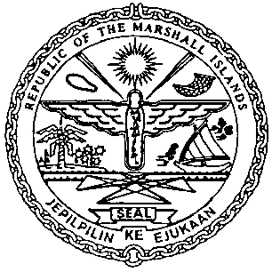 | REPUBLIC OF THE MARSHALL ISLANDS  MARITIME ADMINISTRATOR

MEMORANDUM OF CORRECTIONS

This form is for the sole purpose of correcting an error or omission on the face of an instrument recorded with the Republic of the Marshall Islands Maritime Administrator (“Maritime Administrator”). This is not an amendment to the instrument (including any attachments or appendices) and cannot be used to amend any information contained in the Certificate of Ownership and Encumbrance, or in any certified extract of the public register as maintained by the Maritime Administrator (unless specifically approved).

The corrections contained within this Memorandum of Correction shall be effective as of the date the original instrument was recorded with the Maritime Administrator.

Required Information | Response
Name of Vessel (and Hull Number if instrument is over a vessel under construction)
Official Number or IMO Number
Date of Correction
Information of Recording(s) effected
Detailed Description of Correction (addition, omission, spelling correction, etc.)
Evidence of Authorization
Attachments (including the complete corrected document, and any additional information, if applicable
The undersigned hereby swears and affirms the above and below representations are true and correct:

- That I am authorized to submit this Memorandum of Correction on behalf of the parties to the original recorded instrument and have provided evidence of this as attached.

- That the instrument or document identified requires the correction identified.

- That this correction does not constitute an amendment to the recorded instrument.

- That all the information provided herein and attached is true, correct, and complete.

- To hold harmless, indemnify, and reimburse the Maritime Administrator, The Trust Company of the Marshall Islands, Inc., and any and all of its affiliates, including any employees, representatives, or agents, for any costs, fees or expenses for any claims or liabilities whatsoever arising from the correction of the subject recorded instrument or document.

- That this information will become part of the record as maintained by the Maritime Administrator pursuant to the Republic of the Marshall Islands Maritime Act and may be disclosed as needed.

- That all other versions of the instrument described have been updated in accordance with the above.

For and on behalf of [Name of Party]

By: ___________________________________________________
Name:
Title:

