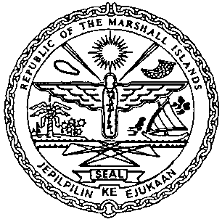 | REPUBLIC OF THE MARSHALL ISLANDS  MARITIME ADMINISTRATOR
Requirements for Subordination Agreement Recordation

Documents to be received prior to recordation:

- Subordination Agreement signed by / on behalf of the Mortgagor, current priority Mortgagee & new priority Mortgagee duly acknowledgedor* notarized (3 hard copies**)

- Memorandum of Particulars (MOP-G) – signed by / on behalf of the Mortgagor, current priority Mortgagee & new priority Mortgagee

- Power of Attorney or Corporate Resolutions for the existing Mortgagor**

- Power of Attorney or Corporate Resolutions or a copy of the Bank Signature Specimen Page for the current priority Mortgagee**

- Power of Attorney or Corporate Resolutions or a copy of the Bank Signature Specimen Page for the new priority Mortgagee**

- Payment of Recordation Fees (See MN-1-005-1 or MN-1-005-2)

Documents to be issued after recordation:

- Certificate of Ownership and Encumbrance

- Blue Backs – to be attached to the back of the original Subordination Agreement and distributed to the Mortgagee, & Mortgagor

- Recording Index Page (to be initialed by the Mortgagor, current priority Mortgagee & new priority Mortgagee representatives – voluntary)

Draft items 1-5 must be sent for pre-clearing prior to recordation.

*If the instrument is to be acknowledged the signor(s) must appear and sign before an authorised RMI representative.

**Any instrument or document may be submitted as an electronic or digital transmission or copy. Such electronic or digital transmissions or copies are deemed the equivalent of an original document or instrument. (See MN-1-012-1)

