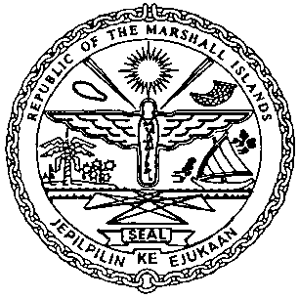 | REPUBLIC OF THE MARSHALL ISLANDS  MARITIME ADMINISTRATOR
Requirements for Notice of Foreign Mortgage Recordation

Documents to be received prior to recordation:

- Memorandum of Particulars - Notice of Foreign Mortgage (MOP-D) and optional formal Notice signed by / on behalf of the Mortgagor, and duly acknowledged* or notarized (3 hard copies**)

- Certificate of Liens issued by current Underlying Registry (dated within 3 working days of recordation)

- Power of Attorney or Corporate Resolutions for the Mortgagor**

- Payment of Recordation Fees (See MN-1-005-1 or MN-1-005-2)

Documents to be issued after recordation:

- Certificate of Ownership and Encumbrance

- Blue Backs - to be attached to the back of the original Notice of Foreign Mortgages and distributed to the Mortgagee, & Mortgagor

- Recording Index Page (to be initialed by the Mortgagor representative – voluntary)

Drafts must be sent for pre-clearing prior to recordation.

*If the instrument is to be acknowledged the signor(s) must appear and sign before an authorised RMI representative.

**Any instrument or document may be submitted as an electronic or digital transmission or copy. Such electronic or digital transmissions or copies are deemed the equivalent of an original document or instrument. (See MN-1-012-1)

