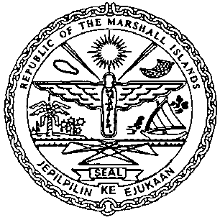 | REPUBLIC OF THE MARSHALL ISLANDS  MARITIME ADMINISTRATOR
Requirements for Preferred Fleet Mortgage Recordation

Documents to be received prior to recordation:

- Preferred Fleet Mortgage signed by/ on behalf of the Mortgagor , and duly acknowledged* or notarized (3 hard copies**)

- Memorandum of Particulars (MOP-A) signed by / on behalf of the Mortgagor

- Power of Attorney or Corporate Resolutions for the Mortgagor**

- Consent of Mortgagee (only required if a prior Mortgage is currently recorded)

- Payment of Recordation Fees for each vessel (See MN-1-005-1)

Documents to be issued after recordation:

- Certificate of Ownership and Encumbrance

- Blue Backs - to be attached to the back of each of the original Preferred Fleet Mortgage
and distributed to the Mortgagee,& Mortgagor

- Recording Index Page (to be initialed by the Mortgagor representative – voluntary)

Drafts item 1-4 must be sent for pre-clearing prior to recordation.

*If the instrument is to be acknowledged the signor(s) must appear and sign before an authorised RMI representative.

**Any instrument or document may be submitted as an electronic or digital transmission or copy. Such electronic or digital transmissions or copies are deemed the equivalent of an original document or instrument. (See MN-1-012-1)

