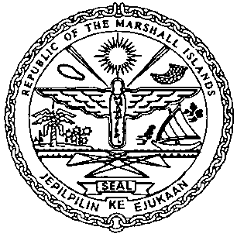 | REPUBLIC OF THE MARSHALL ISLANDS  MARITIME ADMINISTRATOR
Requirements for Financing Charter Recordation

Documents to be received prior to recordation:

- Bareboat Charter Agreement and Amendment (Bareboat Charter Agreement, if already executed, should be presented as a certified copy) signed by / on behalf of the Registered Owner and Charterer, and duly acknowledged* or notarized (3 hard copies**)

- Memorandum of Particulars (MOP-B) signed by / on behalf of the Registered Owner and Charterer

- Power of Attorney or Corporate Resolutions for the Registered Owner**

- Power of Attorney or Corporate Resolutions for the Charterer**

- Consent of Mortgagee (only required if a prior Mortgage is currently recorded)

- Payment of Recordation Fees (See MN-1-005-1 or MN-1-005-2)

Documents to be issued after recordation:
- Certificate of Ownership and Encumbrance

- Blue Backs – to be attached to the back of the original Financing Charter and distributed to the Charterer, & Registered Owner

- Recording Index Page (to be initialed by the Registered Owner and Charterer representatives –voluntary)

Draft items 1-5 must be sent for pre-clearing prior to recordation.

*If the instrument is to be acknowledged the signor(s) must appear and sign before an authorised RMI representative.

**Any instrument or document may be submitted as an electronic or digital transmission or copy. Such electronic or digital transmissions or copies are deemed the equivalent of an original document or instrument. (See MN-1-012-1)

