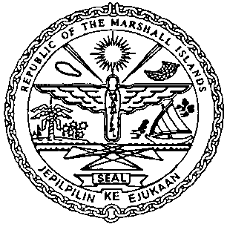 | REPUBLIC OF THE MARSHALL ISLANDS  MARITIME ADMINISTRATOR
Requirements for Release of Preferred Mortgage Recordation

Documents to be received prior to recordation:

- Release of Preferred Mortgage signed by / on behalf on the Mortgagee, and duly acknowledged* or notarized (2 hard copies**)

- Memorandum of Particulars (MOP-E) signed by / on behalf of the Mortgagee

- Power of Attorney or Corporate Resolutions or a copy of the Bank Signature Specimen Page for the Mortgagee**

- Payment of Recordation Fees (See MN-1-005-1 or MN-1-005-2)

Documents to be issued after recordation:

- Certificate of Ownership and Encumbrance

- One Blue Back – to be attached to the back of one of the original Release of Preferred Mortgage and distributed to the Mortgagee

- Recording Index Page (to be initialed by the Mortgagee representative – voluntary)

Draft items 1-3 must be sent for pre-clearing prior to recordation.

*If the instrument is to be acknowledged the signor(s) must appear and sign before an authorised RMI representative.

**Any instrument or document may be submitted as an electronic or digital transmission or copy. Such electronic or digital transmissions or copies are deemed the equivalent of an original document or instrument. (See MN-1-012-1)

