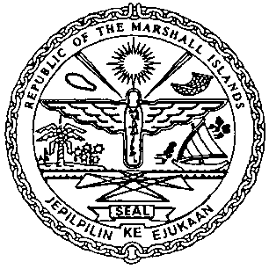 | REPUBLIC OF THE MARSHALL ISLANDS  MARITIME ADMINISTRATOR
Requirements for Bill of Sale Recordation

Documents to be received prior to recordation:

- Bill of Sale signed by / on behalf on the Grantor, duly acknowledged* or notarized

- Power of Attorney or Corporate Resolutions for Grantor**

- Payment of Recordation Fees of (See MN-1-005-1 or MN-1-005-2)

Draft items 1-2 must be sent for pre-clearing prior to recordation.
*If the instrument is to be acknowledged the signor(s) must appear and sign before an authorised RMI representative.

**Any instrument or document may be submitted as an electronic or digital transmission or copy. Such electronic or digital transmissions or copies are deemed the equivalent of an original document or instrument. (See MN-1-012-1)

