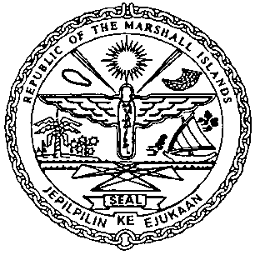 | REPUBLIC OF THE MARSHALL ISLANDS  MARITIME ADMINISTRATOR
Requirements for Continuation of Prior Foreign Mortgage Recordation

Documents to be received prior to recordation:

- Preferred Mortgage granted in Continuation of prior Foreign Mortgagesigned by /
on behalf of the Mortgagor, and duly acknowledged* or notarized (3 hard copies**)

- Executed Foreign Mortgage with English translation, if required (4 certified copies)

- Memorandum of Particulars (MOP-A) signed by / on behalf of the Mortgagor

- Copy of Certificate of Liens issued by Previous Registry
(dated within 3 working days of recordation)

- Power of Attorney or Corporate Resolutions for the Mortgagor**

- Consent of Mortgagee

- Payment of Recordation Fees (See MN-1-005-1 or MN-1-005-2)

Documents to be issued after recordation:
- Certificate of Ownership and Encumbrance

- Blue Backs – to be attached to the back of the original Preferred Mortgages granted in Continuation of Prior Foreign Mortgage and certified copy of the executed Foreign Mortgage and distributed to the Mortgagee, & Mortgagor

- Recording Index Page (to be initialed by the Mortgagor representative – voluntary)

Draft items 1-6 must be sent for pre-clearing prior to recordation.

*If the instrument is to be acknowledged the signor(s) must appear and sign before an authorised RMI representative.

**Any instrument or document may be submitted as an electronic or digital transmission or copy. Such electronic or digital transmissions or copies are deemed the equivalent of an original document or instrument. (See MN-1-012-1)

