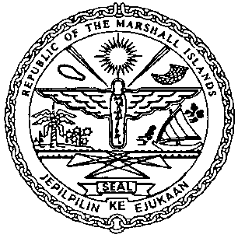 | REPUBLIC OF THE MARSHALL ISLANDS  MARITIME ADMINISTRATOR
Requirements for Preferred Mortgage Recordation

Documents to be received prior to recordation:

- Preferred Mortgage signed by / on behalf of the Mortgagor, and duly acknowledged *
or notarized (3 hard copies**)

- Memorandum of Particulars (MOP-A) signed by / on behalf of the Mortgagor

- Power of Attorney or Corporate Resolutions for the Mortgagor**

- Consent of Mortgagee (only required if a prior Mortgage is currently recorded)

- Payment of Recordation Fees (See MN-1-005-1 or MN-1-005-2)

Documents to be issued after recordation:

- Certificate of Ownership and Encumbrance

- Blue Backs – to be attached to the back of the original Preferred Mortgage and distributed to the Mortgagee, & Mortgagor.

- Recording Index Page (to be initialed by the Mortgagor representative – voluntary)

Draft items 1-4 must be sent for pre-clearing prior to recordation.

*If the instrument is to be acknowledged the signor must appear and sign before an authorised RMI representative.

**Any instrument or document may be submitted as an electronic or digital transmission or copy. Such electronic or digital transmissions or copies are deemed the equivalent of an original document or instrument. (See MN-1-012-1)

