Requirements for Vessel Deletion

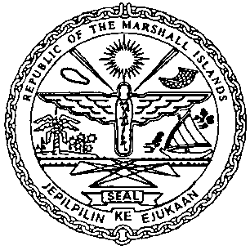 | REPUBLIC OF THE MARSHALL ISLANDS  MARITIME ADMINISTRATOR
Documentation/Requirements:
- Release of Existing Mortgage(s)
- Owner’s Written Request for a Permission to Transfer, including the following where applicable:

- On Company Letterhead
- The name and the domicile of buyer.
- To which registry the vessel will transfer into.
- If the vessel is being sold for the purpose of scrapping then kindly state the same.
- If there is no change to the ownership then kindly state the same.
- The reason for leaving the RMI.

- CSR Amendment Forms (MI-203) and Index (MI-204), if applicable
- Ship Fuel Oil Consumption DCS Form (MI-296), if applicable as per MN 2-013-12, must be submitted to DCS at dcs@register-iri.com when available
- Bill of Sale, if applicable
- Protocol of Delivery and Acceptance, if available
- On the day of Deletion an e-mail confirming one of the following:

- The vessel has been sold.
- The vessel is not under the control of the seller.
- The vessel is no longer flying the RMI flag.

- Payment for Outstanding Maritime (including Vessel Deletion Fees) & Corporate Fees.

Certificates to be Issued:
- Permission to Transfer
- Certificate of Cancellation

Electronic Certificate to be issued post closing:
- Continuous Synopsis Record (CSR), if applicable

