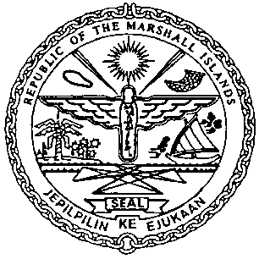 | REPUBLIC OF THE MARSHALL ISLANDS  MARITIME ADMINISTRATOR
Requirements for Termination of Bareboat Charter Registration

Consents and Charter Party Requirements:
- Written Consent of Bareboat Charterer for termination
- Written Consent of Shipowner for termination
- CSR Amendment Form (MI-203) and Index (MI-204)*

Documents to be received on or prior to the day of termination:
- Payment for Termination Bareboat Charter Registration Fee
- Payment for outstanding Maritime invoices, if applicable

Certificate issued on the day of closing:
- Certificate of Deletion of Bareboat Charter Registry Notation

Certificate issued up on all above settled:
- CSR stating the date the vessel terminated the MI BCR*

