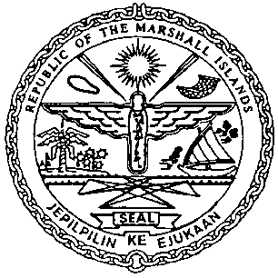 | REPUBLIC OF THE MARSHALL ISLANDS  MARITIME ADMINISTRATOR
Requirements for Renewal of Foreign Bareboat Charter Registration

Vetting Requirements:*
As standard practice, the Administrator undertakes a thorough vetting process of all vessels seeking registration. The vetting process includes due diligence screening of the owning and operating entities, to include actual beneficial ownership of the vessel. For this reason, please identify all natural persons in the vessel ownership structure who ultimately hold a 25% or greater interest in the vessel and indicate the country in which each resides. In the event the vessel ownership structure terminates with no natural person(s) ultimately owning 25% or more interest in the vessel, please provide a statement to that effect and the name(s) of the natural person(s) exercising control of the legal person through other means. Alternatively, if all the ultimate owning legal entities are publicly traded, please provide a statement to that effect and identify the ultimate owning legal entity or entities. This information is kept confidential, but we must have it to satisfy our trade compliance policy

Consents and Charter Party Requirements:
- Owners Application for Permission of renewal of FBCR
- Owner’s Oath/Affirmation of Undertaking, duly acknowledged or notarized *
- Amended or Addendum Charter Party Agreement *
- Agreement between Owner and Charterer *
- Written Consent of Mortgagee for renewal, if applicable*
- Payment of Renewal Foreign Bareboat Charter Registration Fee
- Payment of any open Maritime invoice, if applicable

Documents to be issued / received on or prior to Renewal FBCR Registry certificate:
- Letter of Permission for Renewal Foreign Bareboat Charter Registration
- Certificate of Registry from the Foreign Registry confirming the continued
registration of the vessel*

Certificate issued on the day of Renewal:
- Provisional Certificate of Foreign Bareboat Registry

