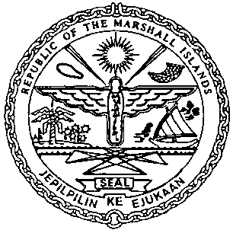 | REPUBLIC OF THE MARSHALL ISLANDS  MARITIME ADMINISTRATOR
Requirements for Renewal of Bareboat Charter Registration

Vetting Requirements:*
As standard practice, the Administrator undertakes a thorough vetting process of all vessels seeking registration. The vetting process includes due diligence screening of the owning and operating entities, to include actual beneficial ownership of the vessel. For this reason, please identify all natural persons in the vessel ownership structure who ultimately hold a 25% or greater interest in the vessel and indicate the country in which each resides. In the event the vessel ownership structure terminates with no natural person(s) ultimately owning 25% or more interest in the vessel, please provide a statement to that effect and the name(s) of the natural person(s) exercising control of the legal person through other means. Alternatively, if all the ultimate owning legal entities are publicly traded, please provide a statement to that effect and identify the ultimate owning legal entity or entities. This information is kept confidential, but we must have it to satisfy our trade compliance policy.
For Bareboat Charter Registrations, the vetting process also includes screening of actual beneficial ownership of the chartering entity. Therefore, please also provide ownership information for the chartering entity conforming to the same standards as those for vessel beneficial ownership above.

Consents and Charter Party Requirements:
- Charterer’s Letter of Request for renewal
- Charterer’s Oath/Affirmation of Undertaking, duly acknowledged or notarized *
- Amended or Addendum Charter Party Agreement *
- Written Consent of Shipowner for renewal *
- Written Consent of Mortgagee for renewal, if applicable *
- Payment of any open Maritime invoices & Renewal Bareboat Charter
Registration Fee

Documents to be issued / received on or prior to Renewal BCR Registry certificate:
- Letter of Consent to Renew Bareboat Charter Registration, if requested
- Intention to Withdraw the Right to Fly the Present Flag
- Certificate Setting Forth Liens/Encumbrances issued by the underlying Registry
(dated within 30 days before renewal)

Certificates issued on the day of Renewal:
- Provisional Certificate of Bareboat Registry
- Port Authority Letter

