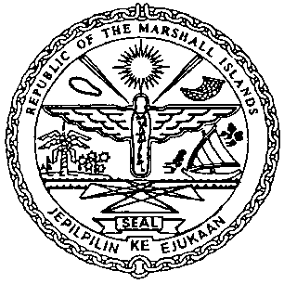 | REPUBLIC OF THE MARSHALL ISLANDS  MARITIME ADMINISTRATOR
Requirements for Re-Registration Private Yacht less than 24m

Vetting Requirements:
As standard practice, the Administrator undertakes a thorough vetting process of all vessels seeking registration. The vetting process includes due diligence screening of the owning and operating entities, to include actual beneficial ownership of the vessel. For this reason, please identify all natural persons in the vessel ownership structure who ultimately hold a 25% or greater interest in the vessel and indicate the country in which each resides. In the event the vessel ownership structure terminates with no natural person(s) ultimately owning 25% or more interest in the vessel, please provide a statement to that effect and the name(s) of the natural person(s) exercising control of the legal person through other means. Alternatively, if all the ultimate owning legal entities are publicly traded, please provide a statement to that effect and identify the ultimate owning legal entity or entities. This information is kept confidential, but we must have it to satisfy our trade compliance policy.

Ownership Structure:
Every RMI registered yacht must be owned through a RMI Entity or a Foreign Maritime Entity.
For more information, please contact our Corporate department: corp@register-iri.com .

Application/Documentation/Requirements:
- Application for Registration, duly acknowledged or notarized (MI-101U),
- Power of Attorney or Corporate Resolutions: Authority of Agent/Officer.
- Third Liability and Hull Machinery Insurance.
- Payment for Registration Fee, refer to the attached Marine Notice (MN-1-005-2) the fee is based on the GT of the yacht.

Closing Documents to be received on or prior to the day of Registration:
- RMI Certificate of Free Ownership and Encumbrances (COE) issued (dated within 3 working days of Re-registration)
- Permission to Sell
- Sellers Power of Attorney or Copy of Corporate Resolutions authorizing the signatory on the BOS
- Bill of Sale (BOS), duly notarized or acknowledged
- Protocol of Delivery and Acceptance, if available
- Non-Registration Letter, if applicable

Certificates issued on the day of closing:
- Private Certificate of Registry
- Temporary Authority Ship Radio License
- Port Authority Letter
- Tonnage Tax Receipt if yacht change name also too
- Waiver of the Marshall Islands Age, if applicable for vessels over 20 years of age
The initial forms to be submitted in draft format would be the MI-101U and the Vetting Requirements, this will give us sufficient information to start our procedures and assign Marshall Islands identifiers.

