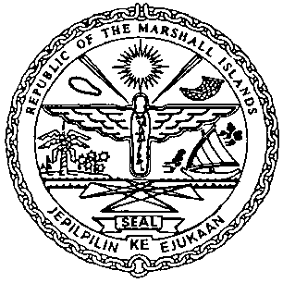 | REPUBLIC OF THE MARSHALL ISLANDS  MARITIME ADMINISTRATOR
Requirements for Change of Private Yacht Name less than 24m

Vetting Requirements:
As standard practice, the Administrator undertakes a thorough vetting process of all vessels seeking registration. The vetting process includes due diligence screening of the owning and operating entities, to include actual beneficial ownership of the vessel. For this reason, please identify all natural persons in the vessel ownership structure who ultimately hold a 25% or greater interest in the vessel and indicate the country in which each resides. In the event the vessel ownership structure terminates with no natural person(s) ultimately owning 25% or more interest in the vessel, please provide a statement to that effect and the name(s) of the natural person(s) exercising control of the legal person through other means. Alternatively, if all the ultimate owning legal entities are publicly traded, please provide a statement to that effect and identify the ultimate owning legal entity or entities. This information is kept confidential, but we must have it to satisfy our trade compliance policy.

Application/Documentation/Requirements:
- Declaration of Company (MI-297A)
- Combined Declaration (MI-297B)
- Confirmation of Billing Agent Information (MI-330), if applicable
- Declaration of Private Use-Not for Hire (MI-127PY) duly completed and signed.
The original must be kept onboard
- Payment for Outstanding Maritime Fees & Name Change Fee

Consents:
- Written Consent of Shipowner
- Written Consent of Mortgagee(s), if applicable

Certificates issued on the day of closing:
- Private Certificate of Registry.
- Temporary Authority Ship Radio License.
- Port Authority Letter.
- Tonnage Tax Receipt
Post Delivery Documentation to be followed-up:
- Affirmation Re: Markings (MI-106Y) - to be followed-up within 30 days

