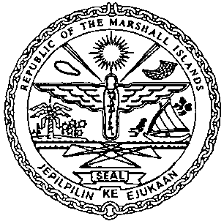 | REPUBLIC OF THE MARSHALL ISLANDS  MARITIME ADMINISTRATOR
Requirements for Change of Name for Private Yacht with Limited Charter (PYLC)

Vetting Requirements:
As standard practice, the Administrator undertakes a thorough vetting process of all vessels seeking registration. The vetting process includes due diligence screening of the owning and operating entities, to include actual beneficial ownership of the vessel. For this reason, please identify all natural persons in the vessel ownership structure who ultimately hold a 25% or greater interest in the vessel and indicate the country in which each resides. In the event the vessel ownership structure terminates with no natural person(s) ultimately owning 25% or more interest in the vessel, please provide a statement to that effect and the name(s) of the natural person(s) exercising control of the legal person through other means. Alternatively, if all the ultimate owning legal entities are publicly traded, please provide a statement to that effect and identify the ultimate owning legal entity or entities. This information is kept confidential, but we must have it to satisfy our trade compliance policy.

Application/Documentation/Requirements:
- Declaration of Company (MI-297A).
- Combined Declaration (MI-297B).
- Confirmation of Billing Agent Information (MI-330), if applicable.
- Application for Minimum Safe Manning Certificate (MI-336Y).
- Declaration of Private Use with Intent to Engage in Limited Charter (MI-127PYLC) duly completed and signed. The original must be kept onboard.
- Wreck Removal Blue Card for vessels over 300 gross tons.
- Payment for Outstanding Maritime Fees & Name Change Fee.

Consents:
- Written Consent of Shipowner.
- Written Consent of Mortgagee(s), if applicable.

Certificates issued on the day of closing:
- Private Yacht Certificate of Registry.
- Temporary Authority Ship Radio License.
- Port Authority Letter.
- Tonnage Tax Receipt
- Minimum Safe Manning Certificate.
- Wreck Removal Liability Certificate.

Post Delivery Documentation to be followed-up:
- Affirmation Re: Markings (MI-106Y) - to be followed-up within 30 days.
- LRIT Conformance Test Report issued under new vessel name.

