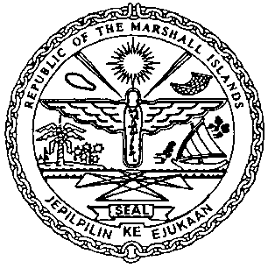 | REPUBLIC OF THE MARSHALL ISLANDS  MARITIME ADMINISTRATOR
Requirements for Change in Gross Tonnage

Application/Documentation/Requirements:
- International Tonnage Certificate (ITC) with updated Gross Tons
- Application for Minimum Safe Manning Certificate (MI-336)
- Wreck Removal Blue Card for vessels over 300 gross tons*
- Payment for Outstanding Maritime Fees
Electronic certificates to be issued:
- Provisional Certificate of Registry OR Permanent Certificate of Registry as applicable
- Minimum Safe Manning Certificate
- Wreck Removal Liability Certificate*
Documentation to be followed-up:
- Issuance of Permanent Radio Certificate – contact radio@register-iri.com
- LRIT CTR - contact Application Service Provider (ASP) for the re-issuance due to
change in GT and send a copy to radio@register-iri.com
- Issuance of new Statement of Compliance for Inventory of Hazardous Materials
(HK/EU) if required – contact ihm@register-iri.com
11. Safety Management Certificate (SMC) issued by RO*
12. International Ship Security Certificate (ISSC) issued by RO*
13. Maritime Labour Certificate (MLC) issued by RO*sent to regulatoryaffairs@register-iri.com
14. Payment for certificates issued for the change of GT

