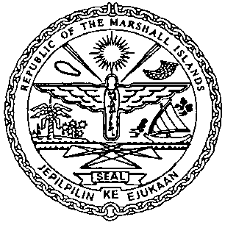 | REPUBLIC OF THE MARSHALL ISLANDS  MARITIME ADMINISTRATOR
Requirements for Foreign Bareboat Charter Registration

Vetting Requirements:
As standard practice, the Administrator undertakes a thorough vetting process of all vessels seeking registration. The vetting process includes due diligence screening of the owning and operating entities, to include actual beneficial ownership of the vessel. For this reason, please identify all natural persons in the vessel ownership structure who ultimately hold a 25% or greater interest in the vessel and indicate the country in which each resides. In the event the vessel ownership structure terminates with no natural person(s) ultimately owning 25% or more interest in the vessel, please provide a statement to that effect and the name(s) of the natural person(s) exercising control of the legal person through other means. Alternatively, if all the ultimate owning legal entities are publicly traded, please provide a statement to that effect and identify the ultimate owning legal entity or entities. This information is kept confidential, but we must have it to satisfy our trade compliance policy.

Application/Documentation/Requirements:
- Power of Attorney or Corporate Resolutions: Authority of Agent/Officer
- Declaration of Company (MI-297A) – ISM Code is Not Applicable
- Combined Declaration (MI-297B) – outlining the Designated Person (DP) for non-ISM Code vessels
- Confirmation of Billing Agent Information (MI-330), if applicable
- Payment for Foreign Bareboat Charter Registration Fee
- CSR Amendment Form (MI-203) and Index (MI-204)*

Consents and Charter Party Requirements:
- Letter of Application for Permission to FBCR
- Owner’s Oath/Affirmation of Undertaking, duly acknowledged or notarized
- or Certified copy of charter party agreement
- Written Consent of Mortgagee(s), if applicable
- Agreement between Owner and Charterer

Closing Documents to be issued/received on or prior to the day of Foreign Bareboat Charter Registration:
- Letter of Permission for Foreign Bareboat Charter Registration
- Certificate of Registry from Foreign Registry showing that the vessel has been Registered

Certificate issued on the day of closing:
- Provisional Certificate of Foreign Bareboat Registry

Electronic Certificate to be issued post closing:
- CSR for Foreign Bareboat Charter Registration*

