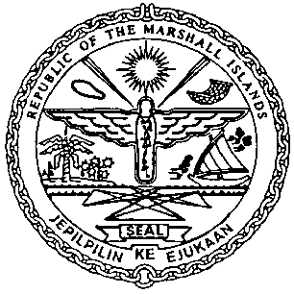 | REPUBLIC OF THE MARSHALL ISLANDS  MARITIME ADMINISTRATOR
Requirements for Change of Registered Owner Name

Vetting Requirements:
As standard practice, the Administrator undertakes a thorough vetting process of all vessels seeking registration. The vetting process includes due diligence screening of the owning and operating entities, to include actual beneficial ownership of the vessel. For this reason, please identify all natural persons in the vessel ownership structure who ultimately hold a 25% or greater interest in the vessel and indicate the country in which each resides. In the event the vessel ownership structure terminates with no natural person(s) ultimately owning 25% or more interest in the vessel, please provide a statement to that effect and the name(s) of the natural person(s) exercising control of the legal person through other means. Alternatively, if all the ultimate owning legal entities are publicly traded, please provide a statement to that effect and identify the ultimate owning legal entity or entities. This information is kept confidential, but we must have it to satisfy our trade compliance policy.

Ownership Structure:
Change in Name of RMI Entity - all name changes including those due to merger or consolidation must be filed in accordance with the RMI Associations Law. For more information, please contact our Corporate department: corp@register-iri.com

Application/Documentation/Requirements:
- Declaration of Company (MI-297A)
- CSR Amendment Form (MI-203) and Index (MI-204)*
- Oil Blue Card for vessels carrying 2000 Tons or more Oil in Bulk*
- Bunker Blue Card for vessels over 1000 gross tons
- Wreck Removal Blue Card for vessels over 300 gross tons*
- Shipowner Liability in Cases of Abandonment Blue Card (Standard A2.5.2), if applicable
- Treatment of Contractual Claims, Death and Long-Term Disability Blue Card
(Standard A4.2.1), if applicable
- Passenger Liability Blue Card for vessels carrying more than 12 passengers,
if applicable*
- Payment

Consents:
- Shipowner Letter /E-mail of Request
- Written Consent of Mortgagee(s), if applicable

Certificates issued on the day of closing:
- Provisional Certificate of Registry
- Temporary Authority Ship Radio License
- Civil Liability Certificate, if applicable
- Civil Liability Bunker Certificate
- Wreck Removal Liability Certificate
- Carriage of Passengers and Luggage Liability Certificate, if applicable*

Electronic Certificate to be issued post closing:
- CSR for Change of Registered Owner Name*

