Requirements for Vessel Change of Class

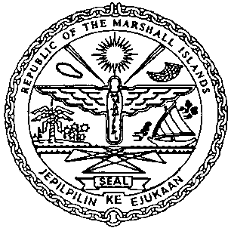 | REPUBLIC OF THE MARSHALL ISLANDS  MARITIME ADMINISTRATOR
Documentation/Requirements:
- New Certificate of Class
- CSR Amendment Forms (MI-203) and Index (MI-204), if applicable
- Proof of Payment for Outstanding Maritime Fees

Certificates to be Issued:
- Provisional Certificate of Registry
Electronic Certificate to be issued post closing:
- Continuous Synopsis Record (CSR), if applicable

