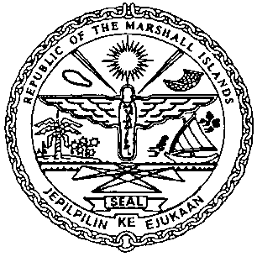 | REPUBLIC OF THE MARSHALL ISLANDS  MARITIME ADMINISTRATOR
Requirements for Vessel Re-Registration (Sellers)

Requirements for Re-registration (Sellers)
- Request Letter for Permission to Sell
- Sellers Power of Attorney or Corporate Resolutions authorizing the signatory
on the Bill of Sale
- Payment

Closing Documents to be received on or prior to the day of Registration:
- Bill of Sale, duly notarized or acknowledged, this may be submitted by the Buyer
- Protocol of Delivery and Acceptance, if available, this may be submitted by the Buyer

Certificates issued on or prior to the day of closing:
- Permission to Sell
- Certificate of Ownership and Encumbrances (COE), if requested

