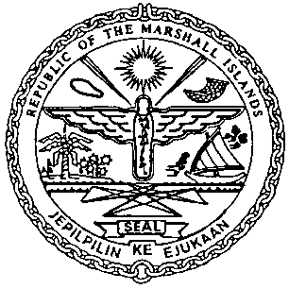

REPUBLIC OF THE MARSHALL ISLANDS

Maritime Administrator
11495 COMMERCE PARK DRIVE
RESTON, VIRGINIA 20191-1506
TELEPHONE: +1-703-620-4880
Email: maritime@register-iri.com
FAX: +1-703-476-8522

(To be filled out by Company or Ship’s Master)

AMENDMENTS TO THE CONTINUOUS SYNOPSIS RECORD (CSR)
DOCUMENT NUMBER FOR THE SHIP WITH IMO NUMBER: IMO

The amendments are shown in the table. Indicate N/C for all items not being changed. Dates should be in the format yyyy/mm/dd
Information
1 | This document applies from (date):
2 | Flag State:
3 | Date of registration with the State indicated in 2:
4 | Name of ship:
5 | Port of registration:
6 | Name of current registered owner(s):
 | Registered address(es):
7 | IMO Registered Owner #
8 | If applicable. name of current registered bareboat charterer(s):
 | Registered address(es):
9 | Name of Company (International Safety Management):
 | Registered address(es):
 | Address(es) of its safety management activities:
10 | IMO Company #
11 | Name of all Classification Societies with which the ship is classed:
12 | Administration/Government/Recognized Organization which issued Document of Compliance:
 | Body which carried out audit (if different):
13 | Administration/Government/Recognized Organization which issued Safety Management Certificate:
 | Body which carried out audit (if different):
14 | Administration/Government/Recognized Organization which issued International Ship Security Certificate:
 | Body which carried out verification (if different):
15 | Date on which the ship ceased to be registered with the State indicated in 2:
16 | Remarks (insert relevant information as appropriate)

THIS IS TO CERTIFY THAT this record is correct in all respects

Issued by the Company or Master:
Date of issue:
Signature of authorized person:
Name of authorized person:

